Anthony Garcia 05/03/2026 Module 7.2
4A Screenshot
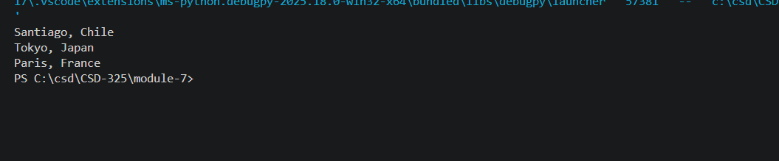
4B Screenshot
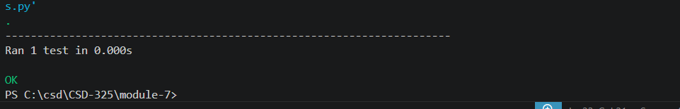
Error
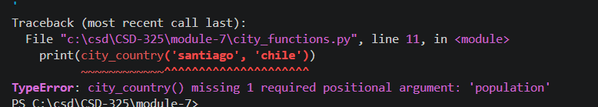
Modify to pass again after error city functions
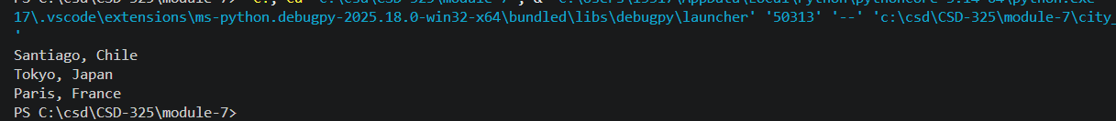
Final test